Order Of Service

Singing: Psalm 51b—CW page 87

Reading: Psalm 32

Opening Hymn: TLH 92

Reading: Revelation 14

Request Hymn: CW Supplement 749

Reading: John 7:40-52

Sermon Hymn: TLH 341

Sermon Text: Song Of Solomon 5:11

His Head & Locks

Prayer

The Apostles’ Creed, TLH page 12

Holy Communion

The Lord's Prayer

The Blessing

Closing Hymn: TLH 97

* * * * * * * * * * *

Bible Study: Lambs: Revelation 19:16; King of kings
Sheep: Proverbs 12:25-28
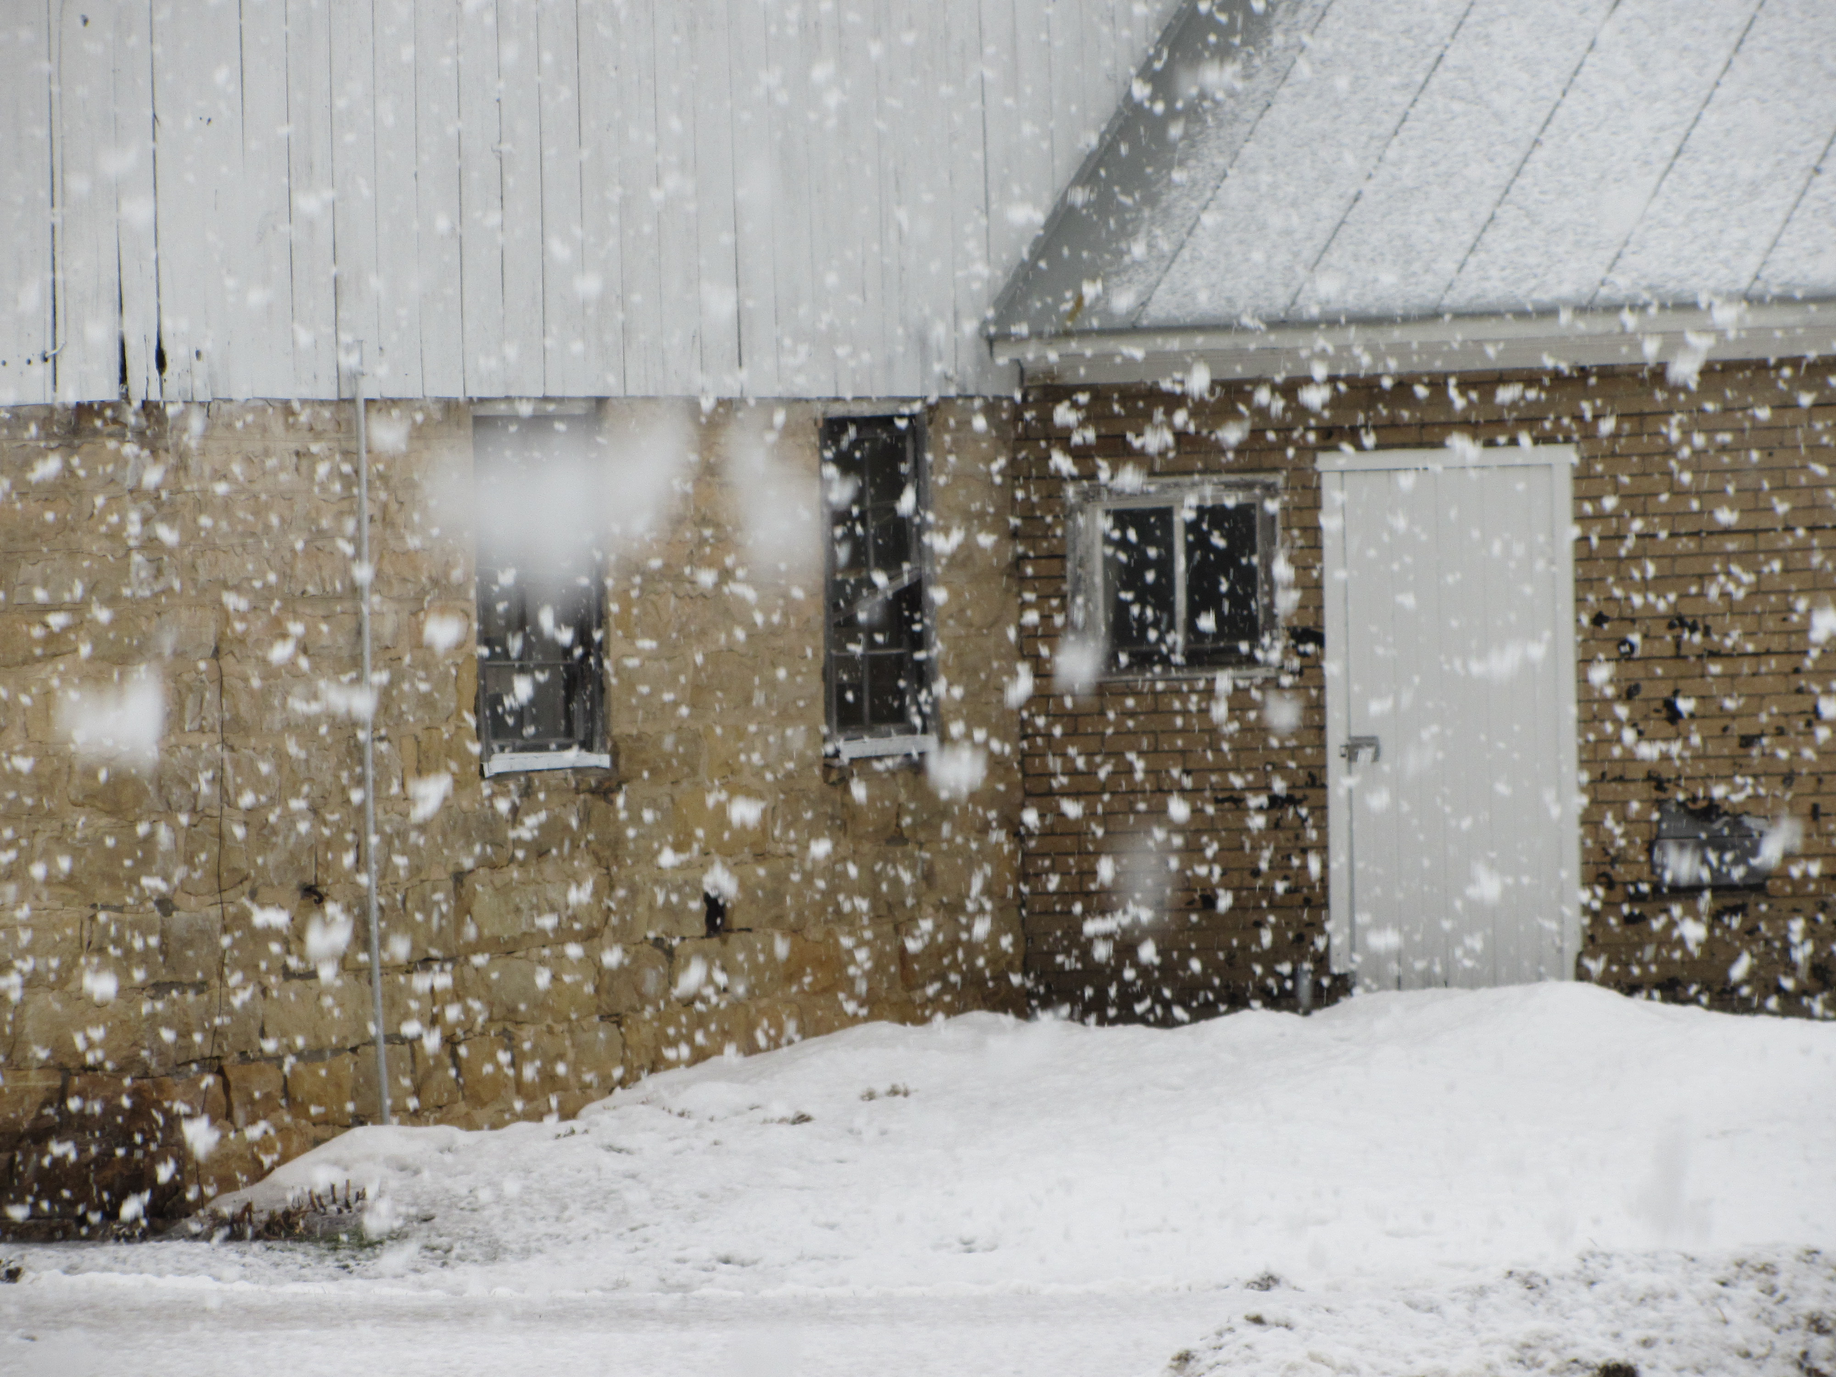

Snow Storm in the Valley

Water
Of
Life

29 January 2017

W A T E R O F L I F E

Independent Christian Church—Conservative Lutheran Doctrine

Worship Service: 9:30 a.m. Bible Study: 10:45 a.m.

Larry Cooper, Pastor E-Mail address:
111 N. Ridge Road lcooper@wateroflife.cc
Coon Valley, WI 54623 Web Site:
Phone: (608) 452-2105 www.wateroflife.cc

* * * * * * * * * * * * * * * * * * * * * * * * * * *

Sermon Text: Song Of Solomon 5:11

His Head & Locks

* * * * * * * * * * * * * * * * * * * * * * * * * * *

Song of Solomon 5:11 His head is as the most fine gold, his locks are bushy, and black as a raven.

Related Passage: Revelation 1:8-20

8 I am Alpha and Omega, the beginning and the ending, saith the Lord, which is, and which was, and which is to come, the Almighty.
9 I John, who also am your brother, and companion in tribulation, and in the kingdom and patience of Jesus Christ, was in the isle that is called Patmos, for the word of God, and for the testimony of Jesus Christ.
10 I was in the Spirit on the Lord's day, and heard behind me a great voice, as of a trumpet,
11 Saying, I am Alpha and Omega, the first and the last: and, What thou seest, write in a book, and send it unto the seven churches which are in Asia; unto Ephesus, and unto Smyrna, and unto Pergamos, and unto Thyatira, and unto Sardis, and unto Philadelphia, and unto Laodicea.
12 And I turned to see the voice that spake with me. And being turned, I saw seven golden candlesticks;
13 And in the midst of the seven candlesticks one like unto the Son of man, clothed with a garment down to the foot, and girt about the paps with a golden girdle.
14 His head and his hairs were white like wool, as white as snow; and his eyes were as a flame of fire;
15 And his feet like unto fine brass, as if they burned in a furnace; and his voice as the sound of many waters.
16 And he had in his right hand seven stars: and out of his mouth went a sharp twoedged sword: and his countenance was as the sun shineth in his strength.
17 And when I saw him, I fell at his feet as dead. And he laid his right hand upon me, saying unto me, Fear not; I am the first and the last:
18 I am he that liveth, and was dead; and, behold, I am alive for evermore, Amen; and have the keys of hell and of death.
19 Write the things which thou hast seen, and the things which are, and the things which shall be hereafter;
20 The mystery of the seven stars which thou sawest in my right hand, and the seven golden candlesticks. The seven stars are the angels of the seven churches: and the seven candlesticks which thou sawest are the seven churches.

